# Exercise: Flexbox - Cards with CSS Columns and Flexbox

Create a web page like the following:

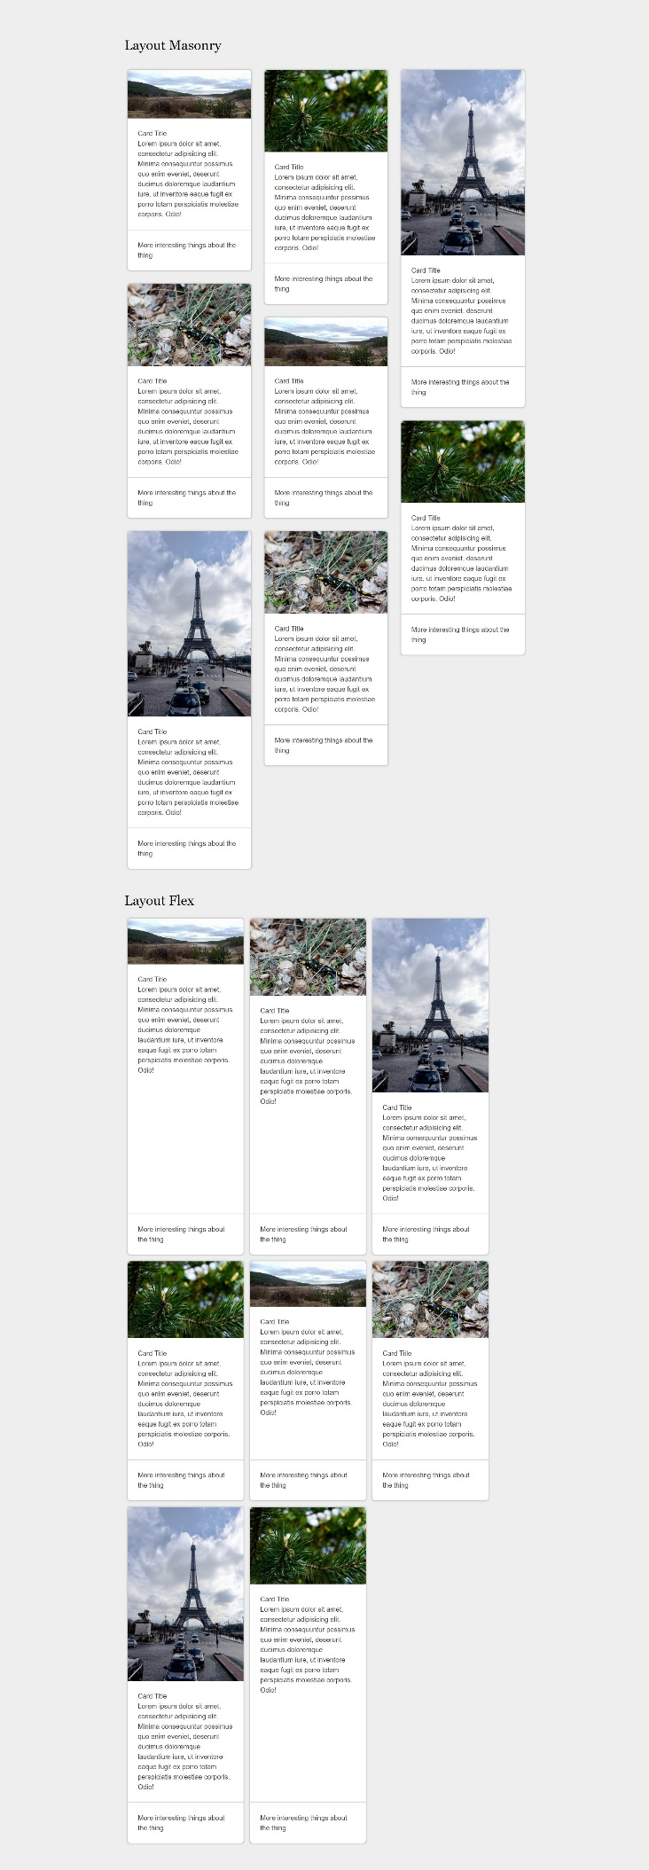

### Constraints

* Change the document title to "**Cards with CSS Columns and Flexbox**"
* Body background color must be rgb(238, 238, 238)
* The content should be divided in two parts:
  + First part is container unit (div) with classes cards-layout and masonry
  + Second part is container unit (div) with classes cards-layout and flex
* Use h2 for the heading